绝密★启用前
2019年普通高等学校招生全国统一考试(江苏卷)
英 语
(满分：120分钟，考试时间：120分)
注 意 事 项
考生在答题前请认真阅读本注意事项及各题答题要求。
1. 本试卷共14页，包含选择题(第1题~第70题，共70题)、非选择题(第71题~第81题，共11题)两部分。本卷满分为120分，考试时间为120分钟。考试结束后，请将本试卷和答题卡一并交回。
2. 答题前，请务必将自己的姓名、准考证号用0.5毫米黑色墨水的签字笔填写在试卷及答题卡的规定位置上。
3. 请认真核对监考员在答题卡上所粘贴的条形码上的姓名、准考证号与本人是否相符。
4. 作答选择题，必须用2B铅笔将答题卡上对应选项的方框涂满、涂黑;如需改动，请用橡皮擦干净后，再选涂其他答案。作答非选择题，必须用0.5毫米黑色墨水的签字笔在答题卡上的指定位置作答，在其他位置作答一律无效。
第一部分 听力(共两节，满分 20 分)
做题时，先将答案标在试卷上。录音内容结束后，你将有两分钟的时间将试卷上的答案转涂到答题卡上。
第一节 (共5小题;每小题1分，满分5分)
听下面5段对话。每段对话后有一个小题，从题中所给的A、B、C三个选项中选出最佳选项。听完每段对话后，你都有10秒钟的时间来回答有关小题和阅读下一小题。每段对话仅读一遍。
例：How much is the shirt?
A. £ 19.15. B. £ 9.18. C. £ 9.15.
答案是 C。
1. Where does this conversation take place?
A. In a classroom. B. In a hospital. C. In a museum.
2. What does Jack want to do?
A. Take fitness classes. B. Buy a pair of gym shoes. C. Change his work schedule.
3. What are the speakers talking about?
A. What to drink. B. Where to meet. C. When to leave.
4. What is the relationship between the speakers?
A. Colleges. B. Classmates. C. Strangers.
5. Why is Emily mentioned in the conversation?
A. She might want a ticket.
B. She is looking for the man.
C. She has an extra ticket.
第二节 (共15小题;每小题1分，满分15分)
听下面5段对话或独白。每段对话或独白后有几个小题，从题中所给的A、B、C三个选项中选出最佳选项。听每段对话或独白前，你将有时间阅读各个小题，每小题5秒钟;听完后，各小题将给出5秒钟的作答时间。每段对话或独白读两遍。
听第6段材料，回答第6、7题。
6. How long did James run his business?
A. 10 years. B. 13years. C. 15 years.
7. How does the woman feel about James' situation?
A. Embarrassed. B. Concerned. C. Disappointed.
听第7段材料，回答第8至10题。
8. What has Kate's mother decided to do?
A. Return to school. B. Change her job. C. Retire from work.
9. What did Kate's mother study at college?
A. Oil painting. B. Art history. C. Business administration.
10. What is Kate's attitude toward her mother's decision?
A. Disapproving. B. Ambiguous. C. Understanding.
听第8段材料，回答第11至13题。
11. What is the man doing?
A. Chairing a meeting. B. Hosting a radio program. C. Conducting a job interview.
12. What benefits Mary most in her job?
A. Her wide reading. B. Her leaders' guidance. C. Her friends' help
13. Who will Mary talk about next?
A. Her teacher. B. Her father C. Her mother.
听第9段材料，回答第14至17题。
14. Why does the man seldom do exercise?
A. He lacks motivation.
B. He has a heart problem.
C. He works all the time.
15. What does Jacob Sattelmair probably do?
A. He's an athlete.
B. He's a researcher.
C. He's a journalist.
16. Why does the woman speak of a study?
A. To encourage the man.
B. To recommend an exercise.
C. To support her findings.
17. How much time will the man probably spend exercising weekly?
A. 300 minutes.
B. 150 minute.
C. 75 minutes.
听第10段材料，回答第18至20题。
18. What did the scientists do to the road?
A. They repaired it.
B. They painted it.
C. They blocked it
19. Why are young birds drawn to the road surface?
A. It's warm.
B. It's brown.
C. It's smooth.
20. What is the purpose of the scientists' experiment?
A. To keep the birds there for a whole year.
B. To help students study the birds well.
C. To prevent the birds from being killed.
第二部分：英语知识运用(共两节，满分35分)
第一节：单项填空(共15小题;每小题1分，满分15分)
请认真阅读下面各题，从题中所给的A、B、C、D四个选项中，选出最佳选项，并在答题卡上将该项涂黑。
例：It is generally considered unwise to give a child _______ he or she wants.
A. however B. whatever C. whichever D. whenever
答案是B。
21. We have entered into an age _______ dreams have the best chance of coming true.
D. which A. what C. when D. that
22. The musician along with his band members ___________ ten performances in the last three months.
A. gives B has given C. have given D. give
23. The doctor shares his phone number with the patients __________ they need medical assistance.
A. if only B. as if C. even though D. in case
24. More wind power stations will ____________ to meet the demand for clean energy.
A. take up B. clear up C. hold up D. spring up
25. Scientists have obtained more evidence ___________ plastic is finding its way into the human body.
A. what B. that C. which D. where
26. Nowadays the ___________ for travelling is shifted from shopping to food and scenery.
A. priority B. potential C proportion D. pension
27. Favorable policies are ___________ to encourage employees' professional development.
A. in effect B. in command C. in turn D. in shape
28. Unlike traditional gyms, app-backed gyms offer people ___________ options to exercise.
A. casual B. regular C. flexible D. tight
29. A few months after he had arrived in China, Mr. Smith ___________ in love with the people and culture there.
A. would fall B. had fallen C. has fallen D. fell
30. ___________ the convenience of digital payment, many senior citizens started to use smart phones.
A. To enjoy B. Enjoying C. To have enjoyed D. Enjoy
31. What a pity! You missed the sightseeing, or we _________a good time together.
A. had B. will have C. would have had D. had had
32. China's image is improving steadily, with more countries__________ its role in international affairs.
A. recognizing B. being recognized C. to be recognized D. recognized
33. They are trying to make sure that 5G terminals_________ by 2022 for the Beijing Winer Olympics.
A. will install B. will have been installed C. are installed D. have been installed
34.A city is the product of the human hand and mind, __________ man's intelligence and creativity.
A. resembling B. reflecting C. reviewing D. restoring
35.—Let's take a coffee break.
— __________ We' ve been working for hours.
A. Why bother? B. What for? C. You got me there. D. You said it.
第二节：完形填空(共20小题;每小题1分，满分20分)
请认真阅读下面短文，从短文后各题所给的A、B、C、D四个选项中，选出最佳选项，并在答题卡上将该项涂黑。
Wildlife has been greatly threatened in the modem age. There are species(物种)that are 36 every day. The white-naped crane is a typical example. So scientists are trying their best to 37 the species from going out of existence.
Chris and Tim work at a zoo, helping endangered cranes with their 38 . Emma, a female crane, has been in their 39 since she arrived in 2004.
Born at an international crane foundation, Emma was 40 by human caretakers. This led to an unexpected 41 , though she had a wonderful time there. Emma had 42 taken herself as a crane and become deeply attached to humans. She 43 to live with male cranes, and even had a 44 for killing some of them, which made it 45 for her to become a mother.
46 , the two zookeepers didn’t want to see the extinction(灭绝)of this precious species. With their patience and efforts, they successfully developed a 47 of artificial breeding(人工繁殖)and natural reproduction. This 48 Emma to give birth to five baby cranes.
The two keepers are proud of their productive work. But before they can be 49 , more efforts must be made, because the population of the crane in the wild is on the 50 , and many other species appear headed toward extinction. 51 , not everyone has realized that wildlife has thoughts, feelings, and most importantly, equal rights to survive.
How can we 52 the ever-widening gap that separates us from other animals? Chris and Tim offered us the 53 : human beings took it for granted that their 54 held all the solutions, but maybe their hearts can be a better 55 .
36. A. growing B. migrating C. competing D. disappearing
37. A. ban B. save C. split D. remove
38. A. abortion B. recreation C. reproduction D. administration
40. A. found B. chosen C. raised D. seized
41. A. bonus B. consequence C. victory D. sacrifice
42. A. never B. always C. unluckily D. cheerfully
43. A. liked B. refused C. decided D. hesitated
44. A. gift B. skill C. concern D. reputation
45. A. illegal B. inspiring C. important D. impossible
46. A. Therefore B. Moreover C. However D. Instead
47. A. combination B. collection C. strategy D. system
48. A. forced B. forbade C. taught D. enabled
49. A. defeated B. grateful C. assured D. tolerant
50. A. it B. rise C. agenda D. decline
51. A. In contrast B. After all C. By the way D. On the contrary
52. A. leave B. bridge C. open D. identify
53. A. course B. excuse C. answer D. reward
54. A. brains B. behaviors C. services D. projects
55. A. guide B. treat C. example D. companion
第三部分: 阅读理解(共15 小题; 每小题2 分, 满分30 分)
请认真阅读下列短文, 从短文后各题所给的A、B、C、D 四个选项中, 选出最佳选项, 并在答题卡上将该项涂黑。
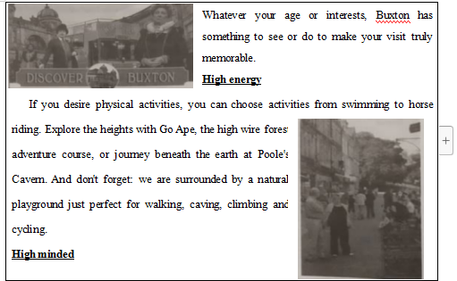
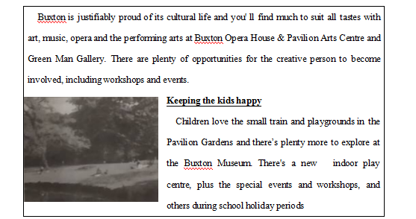
56. If you want to take an undergounld journey, which place is the best choice?
A. Pole's Caven. B. Pavilion Gardens.
C. Buxton Museum. D. Green Man Gallery.
57. Buxton Open House & Pavilion Arts Centre is special because it offers ________.
A. rides in small trains
B. courses in modcm arts
C. artistic and cultural activities
D. basic courses in horse riding
B
In the 1960s，while studying the volcanic history of Yellowstone National Park，Bob Christiansen became puzzled about something that，oddly，had not troubled anyone before：he couldn't find the park's volcano. It had been known for a long time that Yellowstone was volcanic in nature — that's what accounted for all its hot springs and other steamy features. But Christiansen couldn't find the Yellowstone volcano anywhere.
Most of us，when we talk about volcanoes，think of the classic cone(圆锥体)shapes of a Fuji or Kilimanjaro，which are created when erupting magma(岩浆)piles up. These can form remarkably quickly. In 1943，a Mexican farmer was surprised to see smoke rising from a small part of his land. In one week he was the confused owner of a cone five hundred feet high. Within two years it had topped out at almost fourteen hundred feet and was more than half a mile across. Altogether there are some ten thousand of these volcanoes on Earth，all but a few hundred of them extinct. There is，however，a second les known type of volcano that doesn't involve mountain building. These are volcanoes so explosive that they burst open in a single big crack，leaving behind a vast hole，the caldera. Yellowstone obviously was of this second type，but Christiansen couldn't find the caldera anywhere.
Just at this time NASA decided to test some new high-altitude cameras by taking photographs of Yellowstone. A thoughtful official passed on some of the copies to the park authorities on the assumption that they might make a nice blow-up for one of the visitors' centers. As soon as Christiansen saw the photos，he realized why he had failed to spot the caldera; almost the whole park-2.2 million acres—was caldera. The explosion had left a hole more than forty miles across—much too huge to be seen from anywhere at ground level. At some time in the past Yellowstone must have blown up with a violence far beyond the scale of anything known to humans.
58. What puzzled Christiansen when he was studying Yellowstone?
A. Its complicated geographical features.
B. Its ever-lasting influence on tourism.
C. The mysterious history of the park.
D. The exact location of the volcano.
59. What does the second-paragraph mainly talk about?
A. The shapes of volcanoes.
B. The impacts of volcanoes.
C. The activities of volcanoes.
D. The heights of volcanoes.
60. What does the underlined word "blow-up" in the last paragraph most probably mean?
A. Hot-air balloon. B. Digital camera.
C. Big photograph. D. Bird's view.
C
Who cares if people think wrongly that the Internet has had more important influences than the washing machine? Why does it matter that people are more impressed by the most recent changes?
It would not matter if these misjudgments were just a matter of people's opinions. However, they have real impacts, as they result in misguided use of scarce resources.
The fascination with the ICT(Information and Communication Technology) revolution, represented by the Internet, has made some rich countries wrongly conclude that making things is so "yesterday" that they should try to live on ideas. This belief in "post-industrial society" has led those countries to neglect their manufacturing sector(制造业) with negative consequences for their economies.
Even more worryingly, the fascination with the Internet by people in rich countries has moved the international community to worry about the "digital divide" between the rich countries and the poor countries. This has led companies and individuals to donate money to developing countries to buy computer equipment and Internet facilities. The question, however, is whether this is what the developing countries need the most. Perhaps giving money for those less fashionable things such as digging wells, extending electricity networks and making more affordable washing machines would have improved people's lives more than giving every child a laptop computer or setting up Internet centres in rural villages, I am not saying that those things are necessarily more important, but many donators have rushed into fancy programmes without carefully assessing the relative long-term costs and benefits of alternative uses of their money.
In yet another example, a fascination with the new has led people to believe that the recent changes in the technologies of communications and transportation are so revolutionary that now we live in a "borderless world". As a result, in the last twenty years or so, many people have come to believe that whatever change is happening today is the result of great technological progress, going against which will be like trying to turn the clock back. Believing in such a world, many governments have put an end to some of the very necessary regulations on cross-border flows of capital, labour and goods, with poor results.
Understanding technological trends is very important for correctly designing economic policies, both at the national and the international levels, and for making the right career choices at the individual level. However, our fascination with the latest, and our under valuation of what has already become common, can, and has, led us in all sorts of wrong directions.
61. Misjudgments on the influences of new technology can lead to __________.
A. a lack of confidence in technology
B a slow progress in technology
C. a conflict of public opinions
D. a waste of limited resources
62. The example in Paragraph 4 suggests that donators should __________.
A. take people's essential needs into account
B. make their programmes attractive to people
C. ensure that each child gets financial support
D provide more affordable internet facilities
63. What has led many governments to remove necessary regulations?
A. Neglecting the impacts of technological advances.
B. Believing that the world has become borderless.
C. Ignoring the power of economic development.
D. Over-emphasizing the role of international communication.
64. What can we learn from the passage?
A. People should be encouraged to make more donations.
B. Traditional technology still has a place nowadays.
C. Making right career choices is crucial to personal success.
D. Economic policies should follow technological trends.
D
The 65-year-old Steve Goodwin was found suffering from early Alzheimer’s(阿尔楚海默症). He was losing his memory.
A software engineer by profession, Steve was a keen lover of the piano, and the only musician in his family. Music was his true passion, though he had never performed outside the family.
Melissa, his daughter, felt it more than worthwhile to save his music, to which she fell asleep catch night when she was young. She thought about hiring a professional pianist to work with her father.
Naomi, Melissa’s best friend and a talented pianist, got to know about this and showed willingness to help.
“Why do this?” Steve wondered.
“Because she cares.” Melissa said.
Steve nodded, tears in eye.
Naomi drove to the Goodwin home. She told Steve she’d love to hear him play. Steve moved to the piano and sat at the bench, hands trembling as he gently placed his fingers on the keys.
Naomi put a small recorder near the piano, Starts and stops and mistakes. Long pauses, heart sinking. But Steve pressed on, playing for the first time in his life for a stranger.
“It was beautiful." Naomi said after listening to the recording. “The music was worth saving.”
Her responsibility, her privilege, would be to rescue it. The music was sill in Steve Goodwin. It was bidden in rooms with doors about to be locked.
Naomi and Steve met every other week and spent hours together. He’d move his fingers clumsily on the piano, and then she’d take his place. He struggled to explain what he heard in his head. He stood by the piano, eyes closed, listening for the first time to his own work being played by someone else.
Steve and Naomi spoke in musical code lines, beats, intervals, moving from the root to end a song in a new key. Steve heard it. All of it. He just couldn’t play it.
Working with Naomi did wonders for Steve. It had excited within him the belief he could write one last song. One day, Naomi received an email. Attached was a recording, a recording of loss and love, of the fight. Steve called it “Melancholy Flower”.
Naomi heard multiple stops and starts, Steve struggling, searching while his wife Joni called him “honey” and encouraged him. The task was so hard, and Steve, angry and upset, said he was quitting. Joni praised him, telling her husband this could be his signature piece.
Naomi managed to figure out 16 of Steve’s favorite, and most personal songs. With Naomi’s help, the Goodwin family found a sound engineer to record Naomi playing Steve’s songs. Joni thought that would be the end. But it wasn’t.
In the months leading up to the 2016 Oregon Repertory Singers Christmas concert, Naomi told the director she had a special one in mind: “Melancholy Flower”
She told the director about her project with Steve. The director agreed to add it to the playing list. But Naomi would have to ask Steve’s permission. He considered it an honor.
After the concert, Naomi told the family that Steve’s music was beautiful and professional. It needed to be shared in public.
The family rented a former church in downtown Portland and scheduled a concert. By the day of the show, more than 300 people had said they would attend.
By then, Steve was having a hard time remembering the names of some of his friends. He knew the path his life was now taking. He told his family he was at peace.
Steve arrived and sat in the front row, surrounded by his family. The house lights faded. Naomi took the stage. Her fingers. His heart.
65. Why did Melissa want to save her father’s music?
A. His music could stop his disease from worsening.
B. She wanted to please her dying old father.
C. His music deserved to be preserved in the family.
D. She wanted to make her father a professional.
66. After hearing Steve’s playing, Naomi ________.
A. refused to make a comment on it
B. was deeply impressed by his music
C. decided to free Steve from suffering
D. regretted offering help to her friend
67. How can the process of Steve’s recording be described?
A. It was slow but productive.
B. It was beneficial to his health.
C. It was tiresome for Naomi.
D. It was vital for Naomi’s career.
68. Before Steve finished “Melancholy Flower," his wife Joni _______.
A. thought the music talent of Steve was exhausted
B. didn’t expect the damage the disease brought about
C. didn’t fully realize the value of her husband’s music
D. brought her husband’s music career to perfection
69. How did Steve feel at the concert held in downtown Portland?
A. He felt concerned about his illness.
B. He sensed a responsibility for music.
C. He regained his faith in music.
D. He got into a state of quiet.
70. What can be a suitable title for the passage?
A. The Kindness of Friends
B. The Power of Music
C. The Making of a Musician
D. The Value of Determination
第四部分：任务型阅读(共10小题;每小题1分，满分10分)
请认真阅读下面短文，并根据所读内容在文章后表格中的空格里填入一个最恰当的单词。
注意：请将答案写在答题卡上相应题号的横线上。每个空格只填一个单词。
The Cost of Thinking
Despite their many differences, all human beings share several defining characteristics. such as large brains and the ability to walk upright on two legs.
The first unique human characteristic is that humans have extraordinarily large brains compared with other animals. It seems obvious that evolution should select for larger brains. Mammals(哺乳动物)weighing sixty kilograms have an average brain size of 200 cm2. Modern man has a brain averaging 1200-1400 cm2. We are so fond of our high intelligence that we assume that when it comes to brain power, more must be better. Unfortunately, that is not the case.
The fact is that a huge brain is a huge drain—consumption of energy—on the body. I's not easy to carry around, especially when boxed inside a massive skull(倾骨). It's even harder to provides energy. In modern man, the brain accounts for about 2-3%of total body weight but it consumes 25% of the body's energy when the body is at rest. By comparison, the brains of apes(类人猿)require only 8%of rest-time energy. Early humans pad for their large brains in two ways. Firstly, they spent more time in search food. Secondly, their muscles grew smaller and weaker. It's hardly an obvious conclusion that this is a good way to survive. A chimpanzee(黑猩猩) can't win an argument with a modern man, but it can tear the man apart like a rag doll.
Another unique human characteristic is that we walk upright. Standing up, it's easier to find food or enemies. In addition, their arms that are unnecessary for moving around are freed for other purposes, like throwing stones or signaling. As a result, humans can perform very complex tasks with their hands.
Yet walking upright has its disadvantage. The bone structure of our ancestors developed for millions of years to support a creature that walked on all fours and has a relatively small head. Adjusting to an upright position was quite a challenge, especially when the bones had to support an extra-large skull. Humankind paid for its broad vision and skillful hands backaches and painful necks.
We assume that a large brain makes huge advantages. It seems obvious that these have made humankind the most powerful animal on earth. But humans enjoyed all of these advantages for a full 2 million years during which they remained weak and marginal creature. Thus humans who lived a million years ago, despite their big brains and sharp stone tools, lived in constant fear of meat-eating animals.
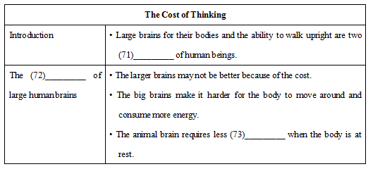
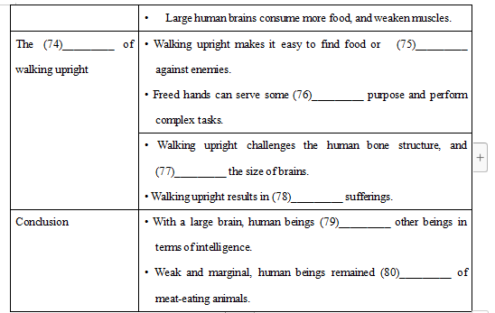
第五部分: 书面表达(满分25 分)
81.请阅读下面文字，并按照要求用英语写一篇150词左右的文章。
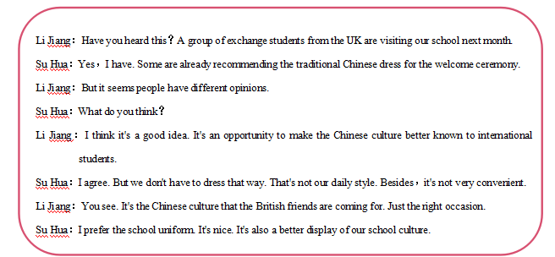
【写作内容】
1.用约30个词概括上述信息的主要内容;
2.在上述场合，你是否倾向于穿中国传统服装?请说明理由(不少于两点)。
【写作要求】
1.写作过程中不能直接引用原文语句;
2.作文中不能出现真实姓名和学校名称;
3.不必写标题。
【评分标准】
内容完整，语言规范，语篇连贯，词数适当。

