第二部分 阅读理解（共两节，满分40分）
(共15题：每小题2分，满分30分)
阅读下列短文，从每题所给的四个选项(A、B、C和D)中，选出最佳选项，并在答题卡上将该项涂黑。
What’s On?
Electric Underground
7.30pm－1.00am Free at the Cyclops Theatre
Do you know who’s playing in your area? We’re bringing you an evening of live rock and pop music from the best local bands. Are you interested in becoming a musician and getting a recording contract(合同)? If so, come early to the talk at 7.30pm by Jules Skye, a successful record producer. He’s going to talk about how you can find the right person to produce you music.
Gee Whizz
8.30pm-10.30pm Comedy at Kaleidoscope
Come and see Gee Whizz perform. He’s the funniest stand-up comedian on the comedy scene. This joyful show will please everyone, from the youngest to the oldest. Gee Whizz really knows how to make you laugh! Our bar is open from 7.00pm for drinks and snacks(快餐).
Simon’s Workshop
5.00pm-7.30pm Wednesdays at Victoria Stage
This is a good chance for anyone who wants to learn how to do comedy. The workshop looks at every kind of comedy, and practices many different ways of making people laugh. Simon is a comedian and actor who has 10 years’ experience of teaching comedy. His workshops are exciting and fun. An evening with Simon will give you the confidence to be funny.
Charlotte Stone
8.00pm-11.00pm Pizza World
Fine food with beautiful jazz music; this is a great evening out. Charlotte Stone will perform songs from her new best-selling CD, with James Pickering on the piano. The menu is Italian, with excellent meat and fresh fish, pizzas and pasta(面食). Book early to get a table. Our bar is open all day, and serves cocktails, coffee, beer, and white wine.
1. Who can help you if you want to have your music produced?
A. Jules Skye. B. Gee Whizz.
C. Charlotte Stone. D. James Pickering.
2. At which place can people of different ages enjoy a good laugh?
A. The Cyclops Theatre B. Kaleidoscope
C. Victoria Stage D. Pizza World
3. What do we know about Simon’s Workshop?
A. It requires membership status. B. It lasts three hours each time.
C. It is run by a comedy club. D. It is held every Wednesday.
4. When will Charlotte Stone perform her songs?
A. 5.00pm-7.30pm. B. 7.30pm－1.00am.
C. 8.00pm-11.00pm. D. 8.30pm-10.30pm.
【答案】1.A 2. B 3. D 4. C
【解析】
试题分析：本文属于广告类阅读，介绍了四则广告，难度较小。本题考生可以使用倒序法，先阅读题目，然后在四则广告中按图索骥即可。
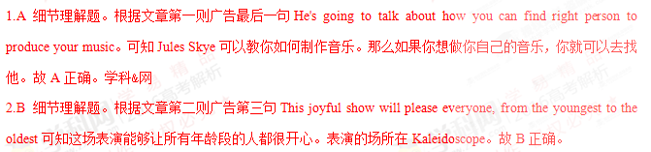 3.D 细节理解题。根据第三则广告第二行中“5.00 pm- 7.30pm Wednesdays at Victoria Stage”可知Simon's Workshop的表演是在每周三下午5点至7点30之间进行。故D项正确。
4.C 细节理解题。根据第四则广告第二行“8.00pm-11.00pm Pizza World”可知Charlotte Stone将在晚上8.00至11点之间表演她最受欢迎的歌曲。故C项正确。
考点：考查广告类阅读
Five years ago, when I taught art at a school in Seattle, I used Tinkertoys as a test at the beginning of a term to find out something about my students. I put a small set of Tinkertoys in front of each student, and said:”Make something out of the Tinkertoys. You have 45 minutes today - and 45minutes each day for the rest of the week.”
A few students hesitated to start. They waited to see the rest of the class would do. Several others checked the instructions and made something according to one of the model plans provided. Another group built something out of their own imaginations.
Once I had a boy who worked experimentally with Tinkertoys in his free time. His constructions filled a shelf in the art classroom and a good part of his bedroom at home. I was delighted at the presence of such a student. Here was an exceptionally creative mind at work. His presence meant that I had an unexpected teaching assistant in class whose creativity would infect(感染) other students.
Encouraging this kind of thinking has a downside. I ran the risk of losing those students who had a different style of thinking. Without fail one would declare, ”But I’m just not creative.”
“Do you dream at night when you’re asleep?”
“Oh, sure.”
“So tell me one of your most interesting dreams.” The student would tell something wildly imaginative. Flying in the sky or in a time machine or growing three heads. “That’s pretty creative. Who does that for you?”
“Nobody. I do it.”
“Really-at night, when you’re asleep?”
“Sure.”
“Try doing it in the daytime, in class, okay?”
5. The teacher used Tinkertoys in class in order to ________?
A. know more about the students B. make the lessons more exciting
C. raise the students’ interest in art D. teach the students about toy design
6. What do we know about the boy mentioned in Paragraph 3?
A. He liked to help his teacher. B. He preferred to study alone.
C. He was active in class. D. He was imaginative.
7. What does the underlined word “downside” in Paragraph 4 probably mean?
A. Mistake. B. Drawback.
C. Difficulty. D. Burden.
8. Why did the teacher ask the students to talk about their dreams?
A. To help them to see their creativity. B. To find out about their sleeping habits.
C. To help them to improve their memory. D. To find out about their ways of thinking.
【答案】5. A 6. D 7. B 8. A
【解析】
试题分析：本文属于记叙文，作者通过让学生拼装玩具发现并鼓励学生的创造性和想象力。
5.A 推理判断题。根据文章第二段可知当我把拼装式玩具放在学生面前的时候，有些学生犹豫着在等着看别人如何行动，有一些学生查看了使用说明并根据模型做出了一些东西。而另外一些学生则根据本人的想象力做出了一些东西。通过观察我对不同的学生的性格有了不同的理解。故A正确。
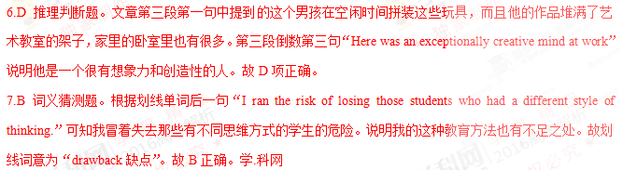 8.A 推理判断题。根据文章最后七段中的对话内容可知作者鼓励孩子们说出最有趣的有创造性和想象力的梦，并鼓励他们在白天的课堂里把梦的内容做出来。作者这样做的目的就是为了让他们看到自己的创造性和想象力。故A正确。
考点：考查记叙文阅读
Reading can be a social activity. Think of the people who belong to book groups. They choose books to read and then meet to discuss them. Now, the website BookCrossing.com turns the page on the traditional idea of a book group.
Members go on the site and register the books they own and would like to share. BookCrossing provides an identification number to stick inside the book. Then the person leaves it in a public place, hoping that the book will have an adventure, traveling far and wide with each new reader who finds it.
Bruce Pederson, the managing director of BookCrossing, says, “The two things that change your life are the people you meet and books you read. BookCrossing combines both.”
Members leave books on park benches and buses, in train stations and coffee shops. Whoever finds their book will go to the site and record where they found it.
People who find a book can also leave a journal entry describing what they thought of it. E-mails are then sent to the BookCrossing to keep them updated about where their books have been found. Bruce peterson says the idea is for people not to be selfish by keeping a book to gather dust on a shelf at home.
BookCrossing is part of a trend among people who want to get back to the “real” and not the virtual(虚拟). The site now has more than one million members in more than one hundred thirty-five countries.
9. Why does the author mention book groups in the first paragraph?
A. To explain what they are.
B.To introduce BookCrossing.
C. To stress the importance of reading.
D. To encourage readers to share their ideas.
10. What does the underlined word “it” in Paragraph 2refer to?
A. The book. B.An adventure.
C.A public place. D. The identification number.
11. What will a BookCrosser do with a book after reading it?
A. Meet other readers to discuss it. B.Keep it safe in his bookcase.
C. Pass it on to another reader. D. Mail it back to its owner.
12. What is the best title for the text?
A. Online Reading: A Virtual Tour B. Electronic Books: A new Trend
C. A Book Group Brings Tradition Back D. A Website Links People through Books
【答案】9. B 10. A11. C 12. D
10.A 代词指代题。根据本句“....hoping that the book will have an adventure, traveling far and wide with each new reader who finds it”那些留下书的人希望自己的书能够随着找到它的人走得更远。可知其中的it指代前半句提到的同一事物“the book”。故A正确。
11.C 推理判断题。根据文章第四段最后一句“....the idea is for people not to be selfish by keeping a book to gather dust on a shelf at home”让书蒙上尘土是一种很自私的行为，网站BookCrossing.com的目的正是鼓励人们与别人分享图书，所以拿到书的人最可能继续把书传递下去。故C项正确。
12.D 标题概括题。根据文章第三段可知BookCrossing.com把人生命中最重要的两个事物：人和书联系在一起。D项内容能够涵盖文章的中心思想。
考点：考查说明文阅读

D
A new collection of photos brings an unsuccessful Antarctic voyage back to life.
Frank Hurley’s pictures would be outstanding----undoubtedly first-rate photo-journalism---if they had been made last week. In fact, they were shot from 1914 through 1916, most of them after a disastrous shipwreck(海滩), by a cameraman who had no reasonable expectation of survival. Many of the images were stored in an ice chest, under freezing water, in the damaged wooden ship.
The ship was the Endurance, a small, tight, Norwegian-built three-master that was intended to take Sir Ernest Shackleton and a small crew of seamen and scientists, 27 men in all, to the southernmost shore of Antarctica’s Weddell Sea. From that point Shackleton wanted to force a passage by dog sled(雪橇) across the continent. The journey was intended to achieve more than what Captain Robert Falcon Scott had done. Captain Scott had reached the South Pole early in 1912 but had died with his four companions on the march back.
As writer Caroline Alexander makes clear in her forceful and well-researched story The Endurance, adventuring was even then a thoroughly commercial effort. Scott’s last journey, completed as be lay in a tent dying of cold and hunger, caught the world’s imagination, and a film made in his honor drew crowds. Shackleton, a onetime British merchant-navy officer who had got to within 100 miles of the South Pole in 1908, started a business before his 1914 voyage to make money from movie and still photography. Frank Hurley, a confident and gifted Australian photographer who knew the Antarctic, was hired to make the images, most of which have never before been published.
13. What do we know about the photos taken by Hurley?
A. They were made last week
B. They showed undersea sceneries
C. They were found by a cameraman
D. They recorded a disastrous adventure
14. Who reached the South Pole first according to the text?
A. Frank Hurley B. Ernest Shackleton
C. Robert Falcon Scott D. Caroline Alexander
15. What does Alexander think was the purpose of the 1914 voyage?
A. Artistic creation B. Scientific research
C. Money making D. Treasure hunting
【答案】13. D 14. C 15. C
35.C 细节理解题。根据文章倒数第二句“....start a business before his 1914 voyage to make money from movie and still photography”可知Alexander认为他的这次航行就是为了挣钱。故C项正确。
考点：考查记叙文阅读
第二节（共5小题；每小题2分，满分10分）
根据短文内容，从短文后的选项中选出能填入空白处的最佳选项。选项中有两项为多余选项。
A garden that’s just right for you
Have you ever visited a garden that seemed just right for you, where the atmosphere of the garden appeared to total more than the sum(总和) of its parts? 16 . But it doesn’t happen by accident. It starts with looking inside yourself and understanding who you are with respect to the natural world and how you approach the gardening process.
●___17
Some people may think that a garden is no more than plants, flowers, patterns and masses of color. Others are concerned about using gardening methods that require less water and fewer fertilizers(肥料). 18 . However, there are a number of other reasons that might explain why you want to garden. One of them comes from our earliest years.
●Recall(回忆)your childhood memories
Our model of what a garden should be often goes back to childhood. Grandma’s rose garden and Dad’s vegetable garden might be good or bad, but that’s not what’s important. 19 --how being in those gardens made us feel. If you’d like to build a powerful bond with your garden, start by taking some time to recall the gardens of your youth. 20 then go outside and work out a plan to translate your childhood memories into your grown-up garden. Have fun.
A. Know why you garden
B. Find a good place for your own garden
C. It’s our experience of the garden that matters
D. It’s delightful to see so many beautiful flowers
E. Still others may simply enjoy being outdoors and close to plants
F. You can produce that kind of magical quality in your own garden, too
G. For each of those gardens, writer down the strongest memory you have
【答案】16. F 17. A 18. E 19. C 20. G
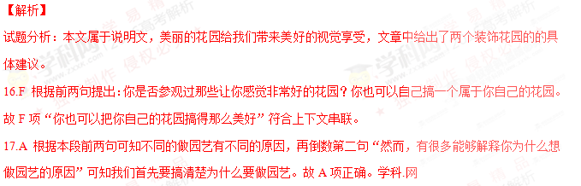 18.E 本段前两句提出有些人认为花园只是一些花花草草，有些人关心少用水少用废料。本句仍然在说明人们对园艺的不同看法。故E项“还有其他人只是喜欢在户外接触植物”与上下文一致，也是人们对于园艺的观点。
19.C 根据前句“......那些都不重要”可知划线句强调的是在园艺中对我们来说真正重要的是什么。故C项“重要的是我们搞园艺的经历”符合上下文串联。
20.G 本部分介绍自己搞一个花园，要回忆一下年轻的时候所看到的那些花园，并把这些花园的优点写下来，然后制定计划并把自己的计划变成美丽的花园。故G项与上下文一致。
考点：考查说明文阅读

第二部分：英语知识运用（共两节，满分45分）
第一节完形填空（共20小题；每小题1.5分，满分30分）
阅读下面短文，从短文后各题所给的四个选项（A、B、C和D）中，选出可以填入空白处的最佳选项，并在答题卡上将该项涂黑。
Hundreds of people have formed impressions of you through that little device(装置)on your desk. And they’ve never actually 21 you. Everything they know about you 22 through this device, sometimes from hundreds of miles away. 23 they feel they can know you 24 from the sound of your voice. That’s how powerful the 25 is.
Powerful, yes, but not always 26 . For years I dealt with my travel agent only by phone. Rani, my faceless agent whom I’d never met 27 , got me rock-bottom prices on airfares, cars, and hotels. But her cold voice really 28 me. I sometimes wished to 29 another agent.
One morning, I had to 30 an immediate flight home for a family emergency. I ran into Rani’s office 31 . The woman sitting at the desk, 32 my madness, sympathetically jumped up. She gave me a 33 smile, nodded while listening patiently, and then printed out the 34 immediately. “What a wonderful lady!” I thought.
Rushing out 35 I called out over my shoulder, “By the way, what’s your name?” “I’m Rani,” she said. I turned around and saw a 36 woman with a big smile on her face waving to wish me a safe trip. I was 37 ! Why had I thought she was cold? Rani was, well, so 38 .
Sitting back in the car on the way to the airport, I figured it all out. Rani’s 39 ---her warm smile, her nods, her ‘I’m here for you’ 40 ---were all silent signals that didn’t travel through wires.
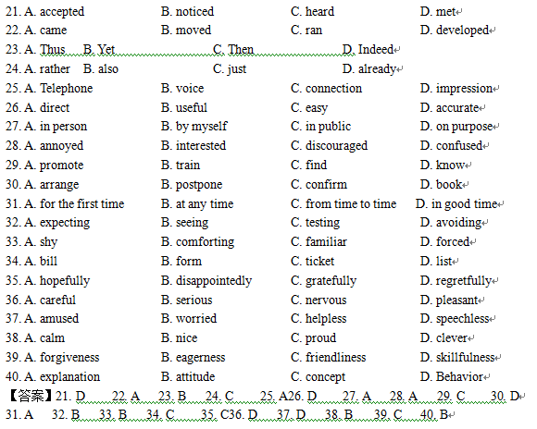
23.B 考查上下文串联。虽然你们之间的距离很远，但是他们只要通过你的声音，就可以了解你。上下文之间是转折关系，所以使用副词yet串联前后语义。故B正确。
24.C 考查副词辨析。副词rather相当地；also也；just只是；already已经；本句使用just表示强调，别人只要通过声音就可以了解你。故C正确。
25.A 考查上下文串联。根据26空后“only by phone”可知本文介绍的是电话，人们可以通过电话了解你。故A正确。
26.D 考查上下文串联。形容词direct直接的；useful有用的；easy容易的；accurate准确的；本空前的but说明上下文之间是转折关系，电话虽然很强大，但是也并不是很准确。与ABC三项语义不搭配。故D正确。
27.A 考查介词辨析。介词in person亲自，by myself靠自己；in public当众；on purpose故意地；A项与空前的faceless形成呼应，Rain是代理人，但是我们从来没有碰过面。故A正确。
28.A 考查上下文串联。空前的cold voice可知Rani在电话里的声音很冷漠，和让我很不高兴，甚至想过要另外找一个代理人。说明我对他的声音很反感。故A正确。
29.C 考查上下文串联。动词promote提拔；train训练；find寻找，找到；know知道；正是因为Rani的声音让我很不舒服，所以我曾经想过另外找代理人取代他。故C正确。
33.B 考查形容词辨析。形容词shy害羞的；comforting安慰的；familiar熟悉的；forced被迫的；她看到我很着急，笑着安慰我。故B正确。
34.C 考查上下文串联。根据30空可知我要预定回家的航班的机票，本句中Rani很快帮我把机票打印出来。故C正确。
35.C 考查上下文串联。副词hopefully充满希望地；disappointedly感到失望地；gratefully感激地；regretfully遗憾地；对方如此迅速地帮我把机票打印出来，而且一直面带微笑，这让我心存感激。故C项正确。
36.D 考查上下文串联。形容词careful细心的；serious严肃的，认真的；nervous紧张的；pleasant令人愉快的；现实生活中的Rani富有同情心，待人热情大方。是一个令人愉快的相处对象。所以当我转身时，看见的是与电话中完全不一样的Rani。故D项正确。
37.D 考查上下文串联。现实生活中的她是如此的体贴大方，而我之前却认为她很冷漠，甚至有了要另找代理的想法，我真是无话可说。说明电话中得到的印象有时很不准确。故D项正确。
38.B 考查上下文串联。在文章28空前“cold”以及前句“...she was cold”之前我因为Rani很冷漠，但却没有想到实际生活中的Rani是如此的美好善良。故B项正确。
39.C 考查名词辨析。名词forgiveness谅解；eagerness急切；friendliness友好；skillfulness熟练；从52-54空内容可知Rani对我非常友好善良，并没有电话中的那种冷漠的感觉。故C项正确。
40.B 考查名词辨析。名词explanation解释；attitude态度；concept概念；behavior行为；Rani的善良友好的态度并没有从电话线中传递过去。B项指Rani接待我的友好的态度。故B项正确。
考点：考查夹叙夹议类阅读
第II卷
注意：将答案写在答题卡上。写在本试卷上无效。
第三部分英语知识运用（共两节，满分45分）
第二节（共10小题；每小题1.5分，满分15分）
阅读下面材料，在空白处填入适当的内容（1个单词）或括号内单词的正确形式。
If you feel stressed by responsibilities at work, you should take a step back and identify (识别)those of 41 (great)and less importance. Then, handle the most important tasks first so you’ll feel a real sense of 42 (achieve). Leaving the less important things until tomorrow 43 (be) often acceptable.
Most of us are more focused 44 our tasks in the morning than we are later in the day. So, get an early start and try to be as productive 45 possible before lunch. This will give you the confidence you need to get you through the afternoon and go home feeling accomplished.
Recent 46 (study) show that we are far more productive at work if we take short breaks 47 (regular). Give your body and brain a rest by stepping outside for 48 while, exercising, or dong something you enjoy.
If you find something you love doing outside of the office, you’ll be less likely 49 (bring) your work home. It could be anything-gardening, cooking, music, sports—but whatever it is, 50 (make) sure it’s a relief from daily stress rather than another thing to worry about.
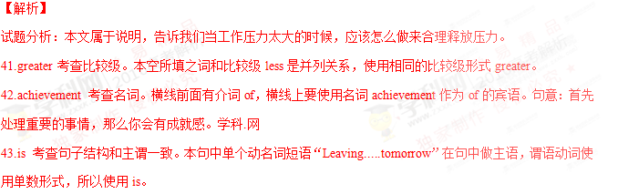 44.on 考查固定搭配。形容词短语be focused on集中于....；很多人早晨对任务的注意力要比晚些时候的注意力更集中。
45.as 考查固定搭配。短语as...as....和...一样；正是因为人们早晨的注意力更为集中，所以我们要早起，要和午饭之前一样的高效率。
46.studies 考查名词单复数。本句的谓语动词是show，说明主语是复数名词studies。
47.regualrly 考查副词。在英语这个副词通常做状语修饰形容词、副词或动词，形容词通常在句中做定语或表语修饰名词。所以本句中使用副词regularly做状语修饰动词take short breaks。
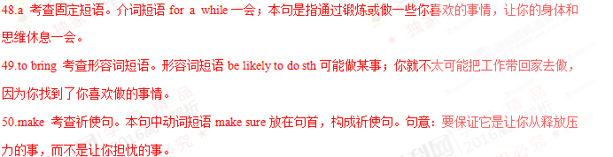考点：考查语法填空

第三部分写作（共两节，满分35分）
第一节短文改错（共10小题，每小题1分，满分10分）
假定英语课上老师要求同桌之间交换修改作文，请你修改你同桌写的以下作文。文中共有10处语言错误，每句中最多有两处。每处错误仅涉及一个单词的增加、删除或修改。
增加：在缺词处加一个漏字符号（∧），并在其下面写出该加的词。
删除：把多余的词用斜线（﹨）划掉。
删除：在错的词下划一横线，并在该词下面写出修改后的词。
注意：1．每处错误及其修改均仅限一词；
2．只允许修改10处，多者（从第11处起）不计分。
The summer holiday is coming. My classmates and I are talking about how to do during the holiday. We can chose between staying at home and take a trip. If we stay at home, it is comfortable but there is no need to spend money. But in that case, we will learn little about world. If we go on a trip abroad, we can broaden you view and gain knowledges we cannot get from books. Some classmates suggest we can go to places of interest nearby. I thought that it is a good idea. It does not cost many, yet we can still learn a lot.
【答案】
1.how改为what 2.chose改为choose 3.take改为taking4.but改为and 5.about后加the
6.your改为our7.knowledges改为knowledge8.删除can或can改为should
9.thought改为think 10.many改为much
【解析】
试题分析：考查记叙文，“我”和同学们对暑假的旅游计划的讨论。
1.how改为what 考查特殊结构。“特殊疑问词+to do”在本句中作为短语talk about的宾语，其中what还要作为动词do的逻辑宾语。句意：同学们和我在谈论暑假期间做什么。
2.chose改为choose 考查句中结构。“情态动词+动词原形”才可以在句中作为谓语部分，而本句中chose是过去式。
3.take改为taking 考查并列结构。本句中动名词短语staying at home与taking a trip构成并列关系，都作为介词between的宾语。
4.but改为and 考查连词。句意：如果我们待在家里，很舒服也没有必要花钱。上下文之间是并列关系，而不是转折关系，所以使用and连接上下文。
5.about后加the 考查定冠词。在英语中定冠词the通常表示特指，本句中the修饰world表示特指这个世界。
6.your改为our 考查代词。应该使用our与本句的主语we保持一致。句意：如果我们出国旅游，我们就拓宽视野并学到书本上学不到的知识。
10.many改为much 考查代词。本句中代词much代替不可数名词much money作为动词cost的宾语，而many通常代替可数名词复数形式。
考点：考查短文改错

第二节书面表达（满分25分）
假定你是李华，你校摄影俱乐部（photography club）将举办国际中学摄影展。请给你的英国朋友Peter写封信。请他提供作品。信的内容包括：
1．主题：环境保护；
2．展览时间；
3．投稿邮箱：intlphotoshow@gmschool.com.
注意：
1．词数100左右；
2．可以适当增加细节，以使行文连贯。
【答案】
Dear Peter,
Our school photography club is going to hold an International High School student Photography Show. The theme of the show is environmental protection. It will start from June
15th and last three weeks. Any students who is interested in welcome to participate. I know you
take good pictures and you've always wanted to do something for environmental protection. I remember you showed me some photos on that themethe last time you visitedour school. This is surely a good chance for more people to see them. If you want to join, youcan send your photos to intlphotoshow@gm.school.com.
Hope to hear from you soon.
Yours
Lihua
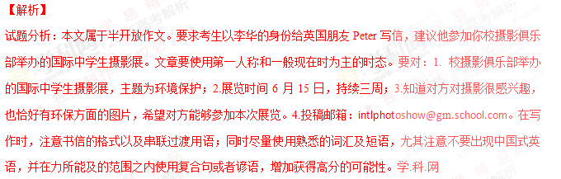考点：考查半开放作文
2016年普通高等学校招生全国统一考试
英语答案及评分参考
第一部分：
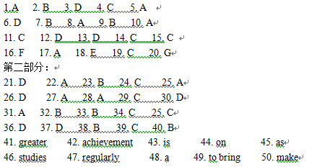
第三部分：
第一节：
The summer holiday is coming. My classmates and I are talking about how to do during the holiday. We can
what
chose between staying at home and take a trip. If we stay at home, it is comfortable but there is no need to spend
choose taking and
money. But in that case, we will learn little about∧ world. If we go on a trip abroad, we can broaden your view
the our
and gain knowledges we cannot get from books. Some classmates suggest we can go to places of interest nearby. I
knowledge can或should
thought that it is a good idea. It does not cost many, yet we can still learn a lot.
think much
第二节：
一、评分原则
1．本题总分为25分，按5个档次给分。
2．评分时，先根据文章内容和语言初步确定其所属档次，然后以该档次的要求来衡量，确定或调整档次，最后给分。
3．词数少于80和多于120的，从总分中减去2分。
4．评分时应注意的主要内容为：内容要应用词汇和语法结构的丰富性和准确性及上下文的连贯性。
5．拼写与标点符号是语言准确性的一个方面。评分时，应视其对交际的影响程度予以考虑。英、美拼写及词汇用法均可接受。
6．如书写较差以至影响交际，将其分数降低一个档次。
二、内容要点
1．举办者；
2．展览主题及时间；
3．邀请对方提供作品；
4．投稿邮箱。
三、One Possible Version
Dear Peter,
Our school photography club is going to hold an International High School Student Photography Show. The theme of the show is environmental protection. It will start from June 15th and last for three weeks. Any student who is interested is welcome to participate. I know you take good pictures and you’ve always wanted to do something for environmental protection. I remember you should me some photos on that theme the last time you visited our school. This is surely a good change for more people to see them. If you want to join, you can send your photos to intlphotoshow@gmschool.com.
Hope to hear from you soon.
Yours,
Li Hua

